

**System Requirements & Design for Graduation Project**

**AI & Data Science Track**

**Land Type Analysis Project**

**Satellitor**

**Powered by Alpha V**

|  |  |
| --- | --- |
| **Team member** | **Contact** |
| **Mohamed Walid** | [**11410120230362@stud.cu.edu.eg**](mailto:11410120230362@stud.cu.edu.eg) |
| **Sherin Mohamed** | [**s-sherin.kamal@zewailcity.edu.eg**](mailto:s-sherin.kamal@zewailcity.edu.eg) |
| **Aly El Deen Yasser** | [**aibakgaming747@gmail.com**](mailto:aibakgaming747@gmail.com) |
| **Dina Zahran** | [**dinazahran1718@gmail.com**](mailto:dinazahran1718@gmail.com) |
| **Amr Yasser** | [**amr855708@gmail.com**](mailto:amr855708@gmail.com) |

Contents

Document Purpose and Audience 3

Purpose of Document. 3

Audience of SRS. 3

Introduction 4

Software Purpose 4

Software Scope 5

Definitions, acronyms, and abbreviations 6

Requirements 7

Functional Requirements 7

Non Functional Requirements 8

System Models 9

Use Case Model 9

# Document Purpose and Audience

## Purpose of Document.

The purpose of this document is to provide a detailed and structured specification of the requirements for the Satellitor system. It is intended to serve as a reference for all stakeholders throughout the software development lifecycle.

This SRS document defines the system’s functional and non-functional requirements, constraints, and overall behavior. It ensures alignment between the development team, stakeholders, and users, and acts as a contractual baseline for what the system is expected to achieve.

## Audience of SRS.

* Developers and Engineers – To understand what needs to be built and how the system should behave.
* Project Managers – To use as a planning and monitoring tool throughout the project.
* Quality Assurance Teams – To derive and design test cases for system validation.
* Clients and End Users – To verify that the system will meet their needs and expectations.
* System Architects and Designers – To ensure the system design aligns with documented requirements.
* Future Maintenance Teams – To refer to for understanding the original goals and structure of the system.

# Introduction

## Software Purpose

The purpose of the Satellitor software is to provide an intelligent, AI-driven platform that analyzes satellite imagery to extract meaningful insights about land areas, especially for agricultural and environmental use cases. The system primarily uses object segmentation and machine learning models to detect, segment, and interpret surface features from satellite images.

Satellitor's core functionality includes:

* Object Segmentation: Applying deep learning models to accurately detect and segment different land regions (e.g., agriculture fields, water bodies, bared area, urban places) from satellite images.
* Soil Analysis: Extracting and estimating key soil attributes such as pH level, moisture, organic content, and composition percentages (e.g., clay, silt, sand).
* Crop Recommendation: Based on segmented land and analyzed soil properties, the system recommend the most suitable crops for a specific area and alternative crops that can be grown in those places.
* Fertilizer Attribute Prediction: Analyzing the land's nutrient profile to predict missing nutrients and classify the necessary fertilizer attributes (e.g., nitrogen, phosphorus, potassium levels).
* Fertilizer Recommendation: Suggesting optimized fertilizer types and quantities based on the soil’s current condition and the recommended crops.
* Stella: A smart assistant module that interacts with users to simplify system usage, explain results, and provide personalized recommendations or clarifications. Stella supports decision-making by translating complex AI outputs into human-friendly insights, acting as a conversational AI layer.
* Report Generation: Automatically generating a comprehensive report that includes:
* Segmented land images
* Soil property analysis
* Recommended crops and fertilizers
* Summary of findings and suggestions for land usage

The Satellitor system is designed to support farmers, agricultural experts, and environmental researchers by transforming raw satellite imagery into actionable insights. The software minimizes manual analysis, boosts precision farming, and promotes data-driven decision-making for sustainable land management.

## Software Scope

The Satellitor system is a web-based software application designed to analyze satellite imagery for the purpose of agricultural and environmental assessment. The system employs advanced computer vision techniques, machine learning models, and a conversational AI assistant to deliver accurate land analysis, actionable recommendations, and intelligent user interaction.

The primary objectives of the system are:

* To segment satellite images using deep learning models to identify land features (e.g., agriculture fields, Baren areas, water bodies, urban places).
* To extract key soil attributes such as PH level, moisture content, and composition percentages (clay, silt, sand).
* To recommend suitable crops for cultivation based on soil and land characteristics.
* To predict soil nutrient deficiencies and recommend appropriate fertilizers tailored to specific crop requirements.
* To generate a comprehensive, human-readable report summarizing all analytical results and system recommendations.
* To provide an intelligent virtual assistant (**Stella**) that interacts with users through natural language to explain results, guide workflows, and personalize recommendations.

This software will be delivered as a responsive web application accessible through modern web browsers and will support interactive analysis workflows for both technical and non-technical users.

**In Scope:**

* Satellite image upload and processing
* Object segmentation using deep learning
* Soil attribute analysis and classification
* Crop recommendation based on soil properties
* Fertilizer attribute prediction and recommendation
* Interactive report generation with visual outputs
* Conversational AI assistant (Stella) for explanations, guidance, and recommendations

**Out of Scope:**

* Real-time weather data integration
* Mobile application version (initial release)
* Support for multiple languages (English only in initial version)
* Real-time satellite data feeds or live Earth imagery
* Mineral Detections and Metals.

The system is intended to serve agricultural specialists, farmers, environmental analysts, and researchers who require automated and interpretable land analysis to support data-driven decision-making in crop planning and land management.

## Definitions, acronyms, and abbreviations

|  |  |
| --- | --- |
| **Terms** | **Definition** |
| NPK | |  | | --- | |  |  |  | | --- | | Nitrogen, Phosphorus, Potassium – the three primary nutrients in fertilizers that affect plant growth. | |
| Stella | The AI-powered virtual assistant integrated into Satellitor that provides natural language interaction, explanations, and recommendations. |
| Segmentation | The process of dividing an image into multiple regions or classes for easier analysis. |
| Soil Composition | The percentage of sand, silt, and clay in the soil, affecting its texture and fertility. |
| pH | A measure of soil acidity or alkalinity, which affects nutrient availability to plants. |
| Report Generation | |  | | --- | |  |  |  | | --- | | The automated creation of a document summarizing system findings, visualizations, and recommendations | |

# Requirements

## Functional Requirements

|  |  |
| --- | --- |
| **Requirement ID** | **Requirement Statment** |
| FR01 | * The system shall allow users to enter longitude and latitude in supported formats. * The system shall validate the image resolution before processing. |
| FR02 | * The system shall display the segmented image with color-coded regions. * The system allows users to choose the opacity of the color-coded regions. * The system allows users to choose between boundaries image and color-coded image. |
| FR03 | * The system shall estimate the pH level of the detected soil areas. * The system shall estimate the type of soil if it is clay, loamy, or sandy. * The system shall estimate soil moisture content and rainfall. |
| FR04 | * The system shall estimate nutrient deficiencies (NPK) in the soil using ML inference. * The system shall recommend fertilizers based on predicted deficiencies. |
| FR05 | The system shall generate a downloadable report (PDF or HTML) summarizing:   * Segmented image * Soil attributes * Crop recommendations * Fertilizer suggestions |
| FR06 | The system allow users to interact with Stella using natural language input. |

## Non Functional Requirements

|  |  |
| --- | --- |
| Measure | Details |
| Performance | * The system shall process satellite images and generate segmented outputs within 30 seconds. * The system shall generate fertilizer and crop recommendations within 20 seconds after the completion of image processing and soil analysis. * The system shall generate the full report within 1 minute of getting the analysis |
| Usability | * The system should have a user-friendly interface that can be navigated by individuals with basic computer skills. * The system should provide **clear error messages** and guidance to users when invalid actions are performed. * Stella, the virtual assistant, shall provide answers in **natural language** and guide users through the platform seamlessly. |
| Maintainability and Extensibility | The system shall be modular, allowing new features (e.g., additional crop types, fertilizer formulations) to be integrated easily. |

# System Models

## Use Case Model

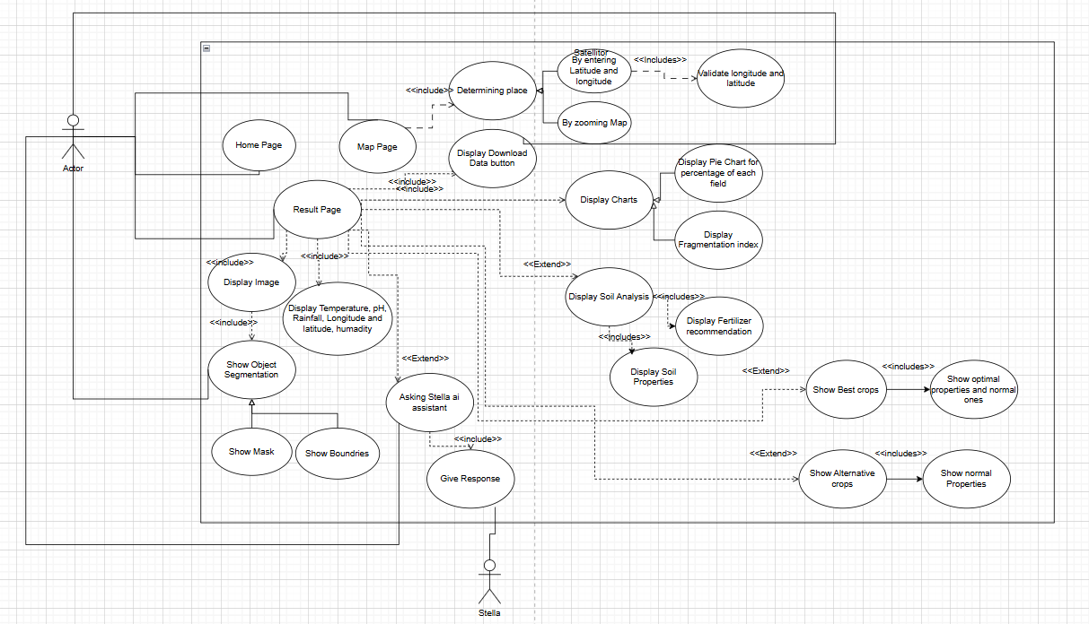

* User: A general user who selects a region on the map to get analysis results and download reports.
* Stella: An internal AI system that performs satellite image analysis, detects features, and generates reports.